**Name :DevaS**

**192210100**

**12.Create a simple cloud software application for Property Buying & Rental process (In Chennai city) using any Cloud Service Provider to demonstrate SaaS include the necessary fields such as Buy, Rent, commercial, Rental Agreement , Rental Agreement, Area, place, Range, property value etc.**

**Step 1:**

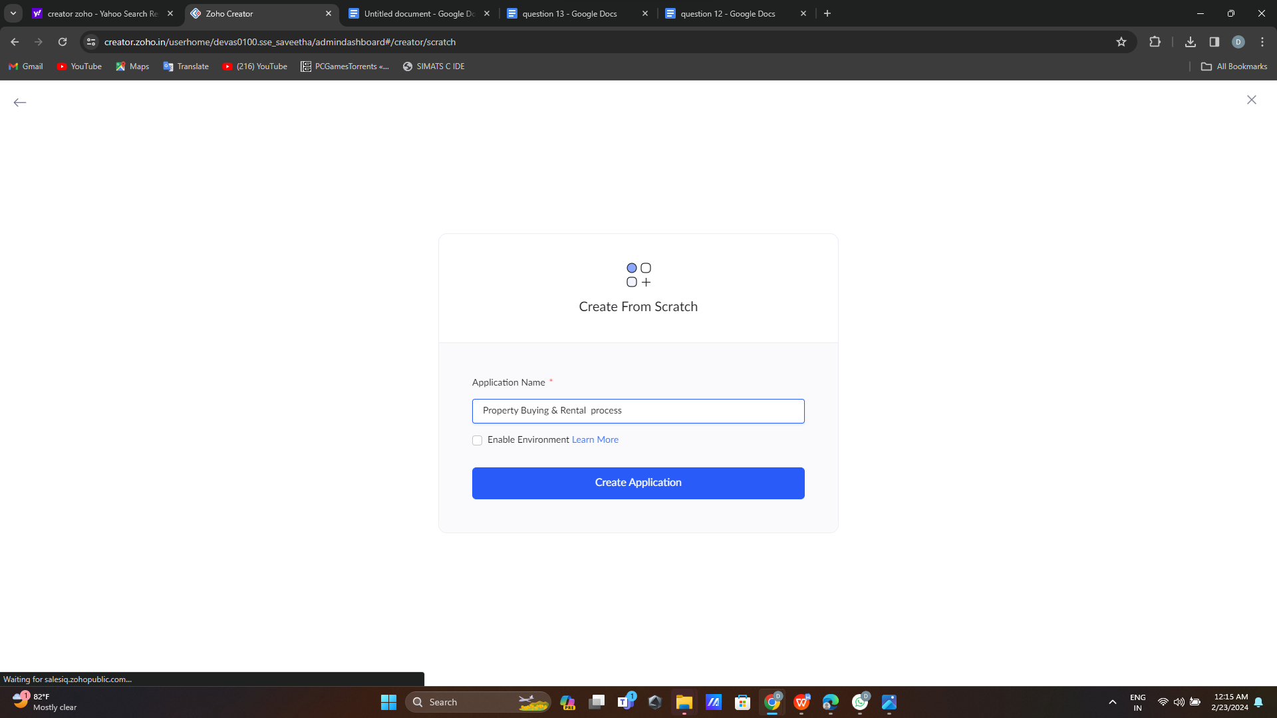

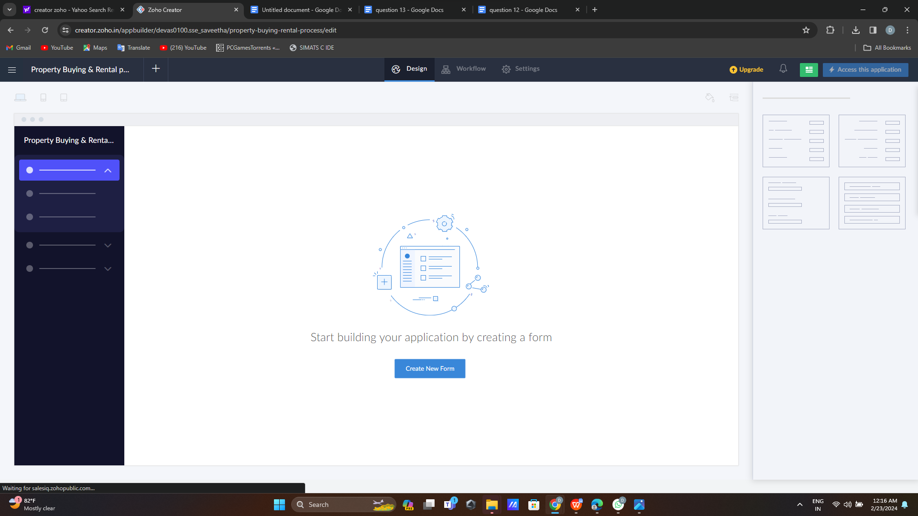

**Step 2:**

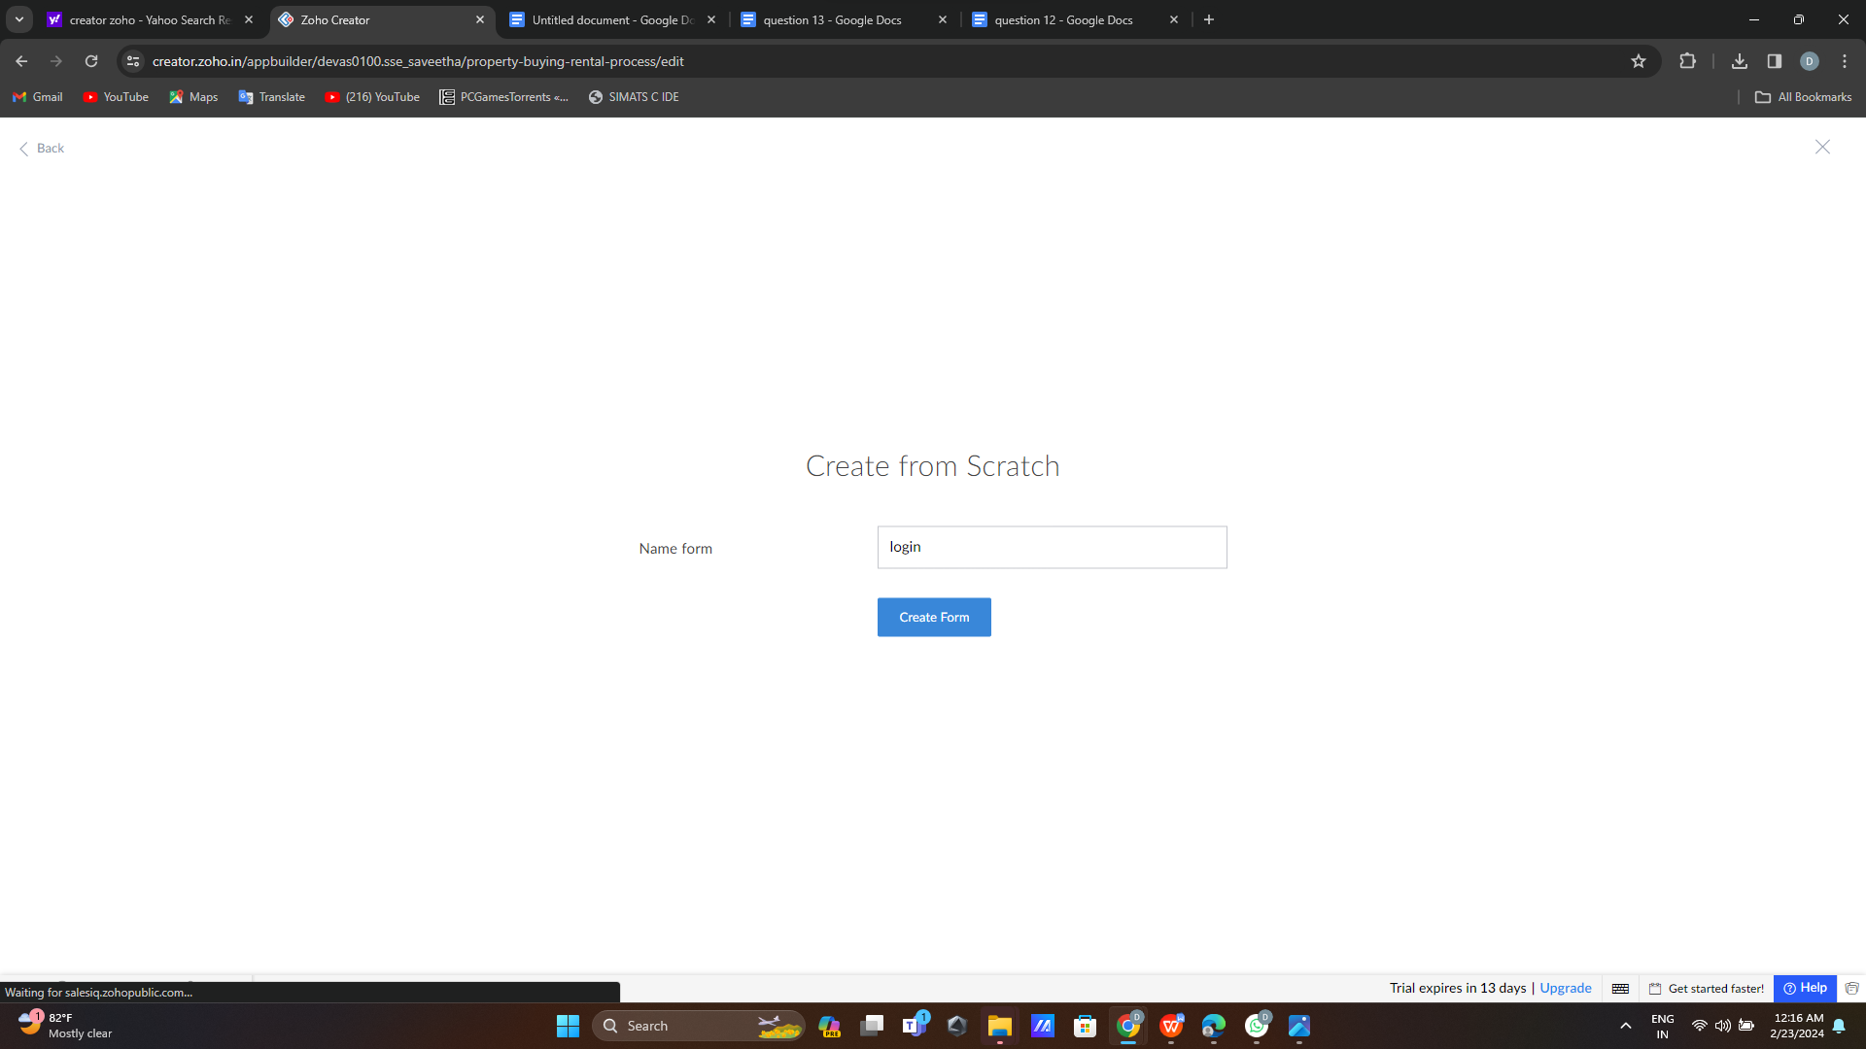

**Step 3:**

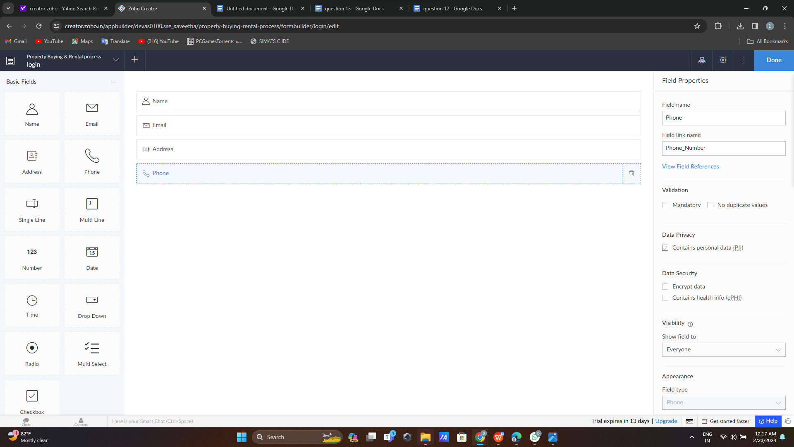

**Step 4:**

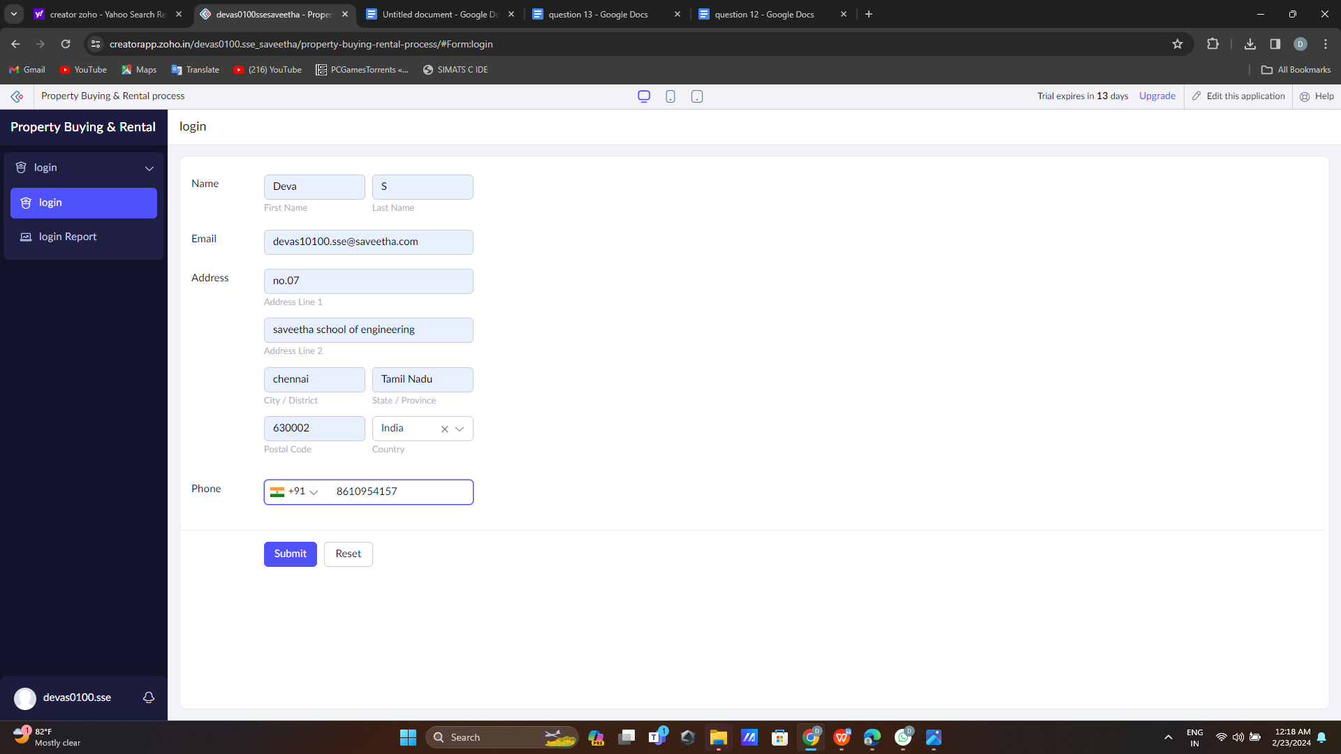

**Step 5:**

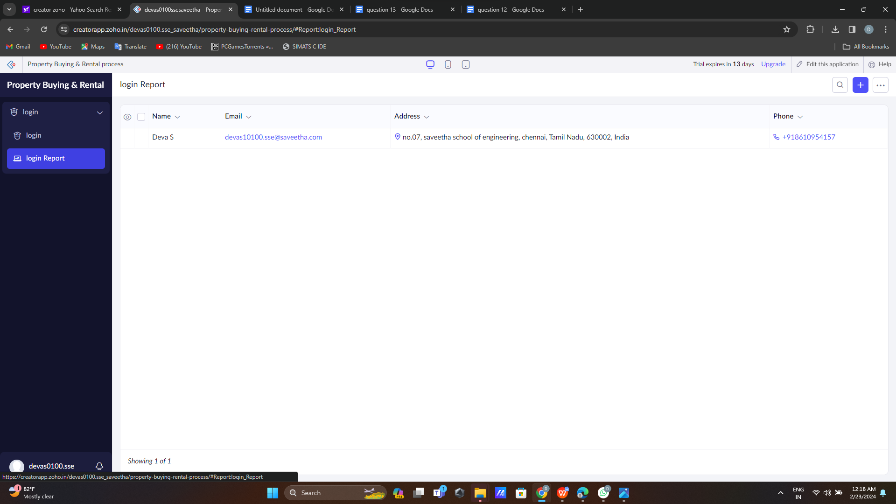

**Step 6:**

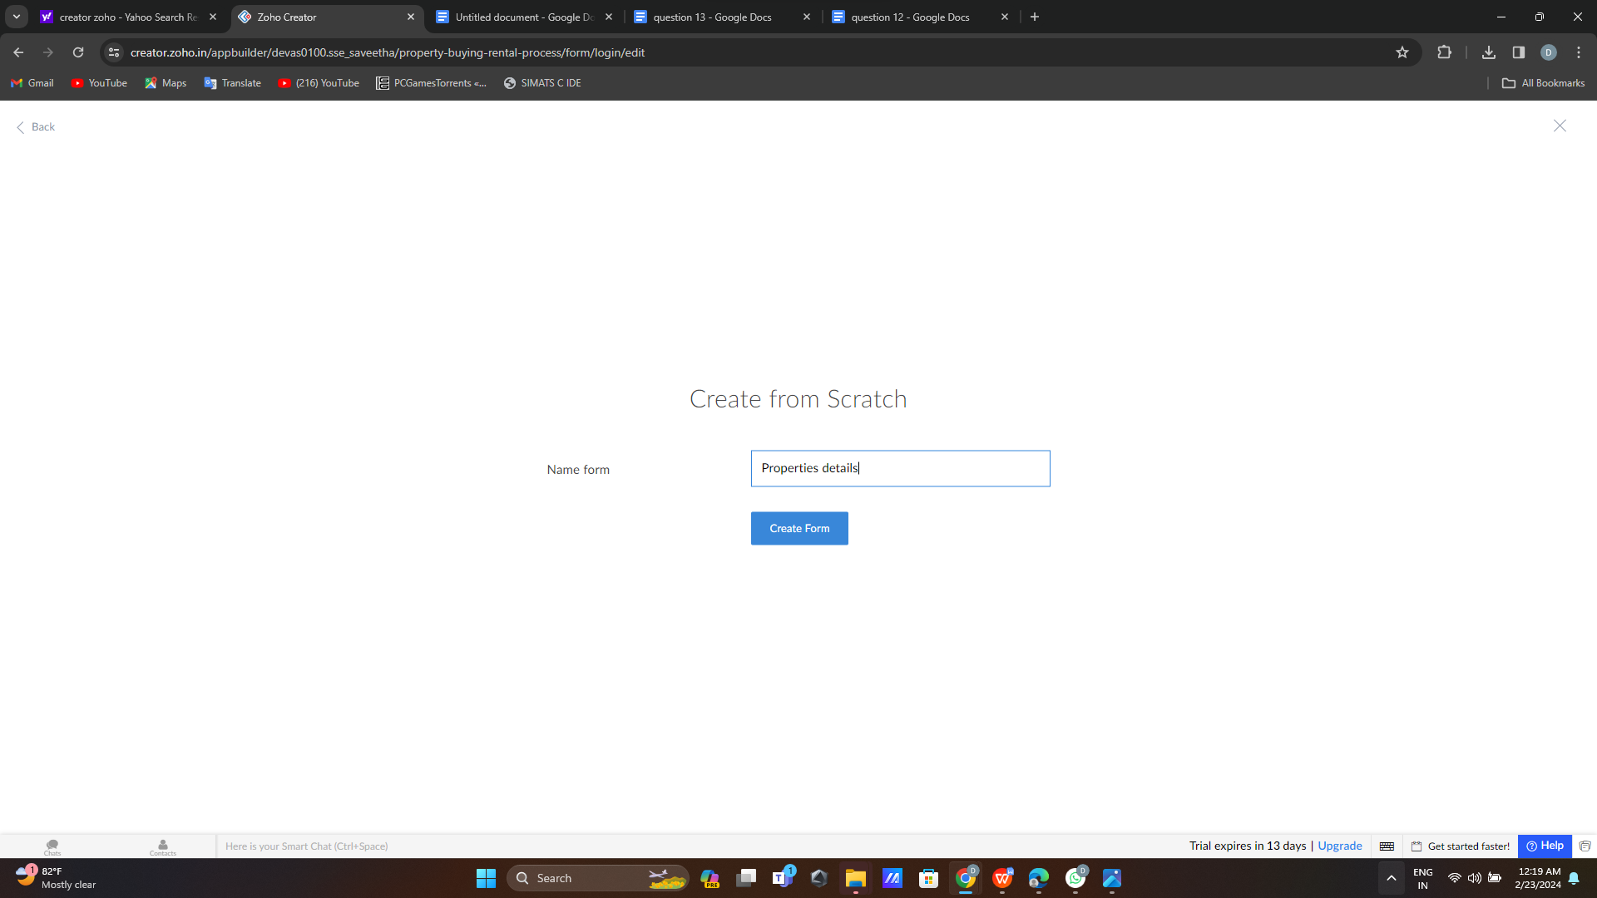

**Step 7:**

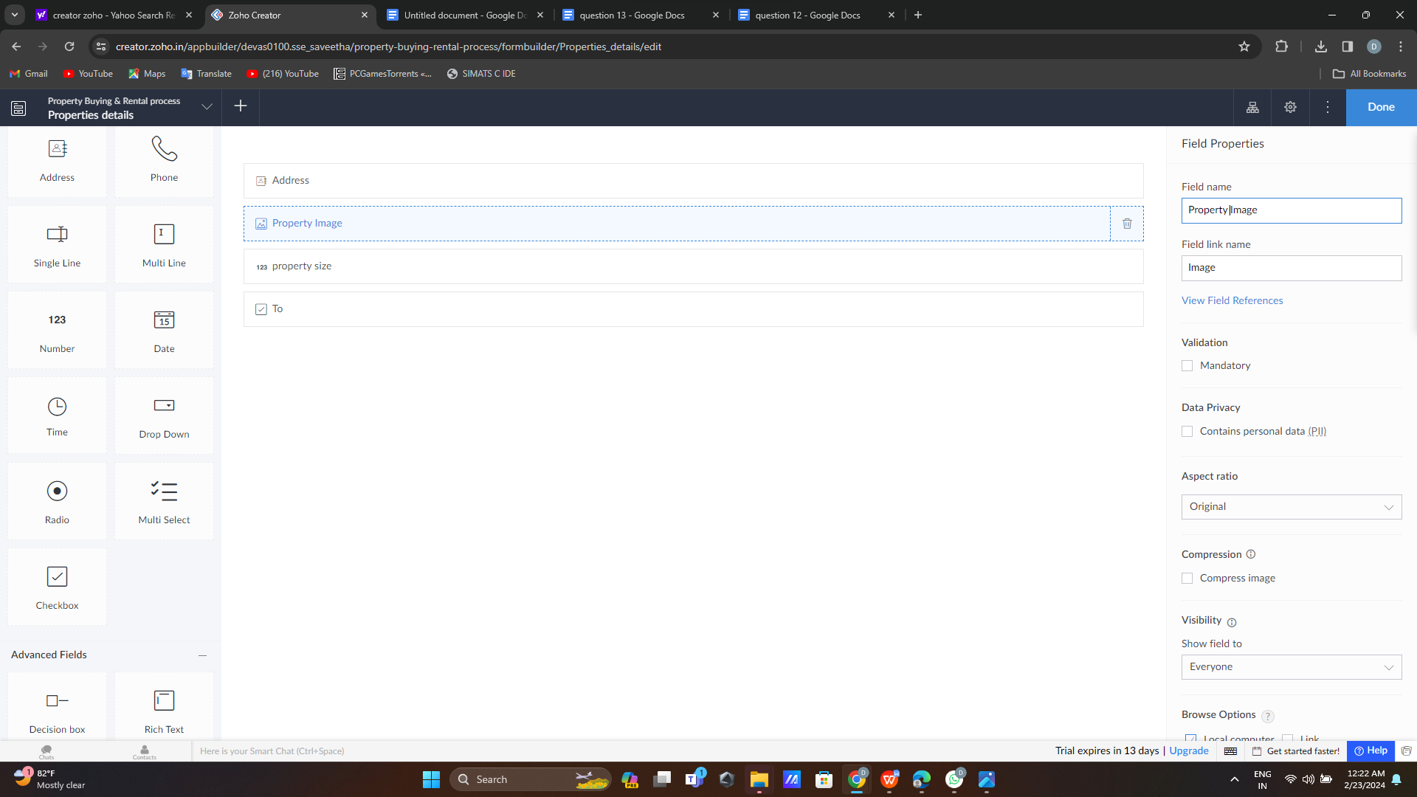

**Step 8:**

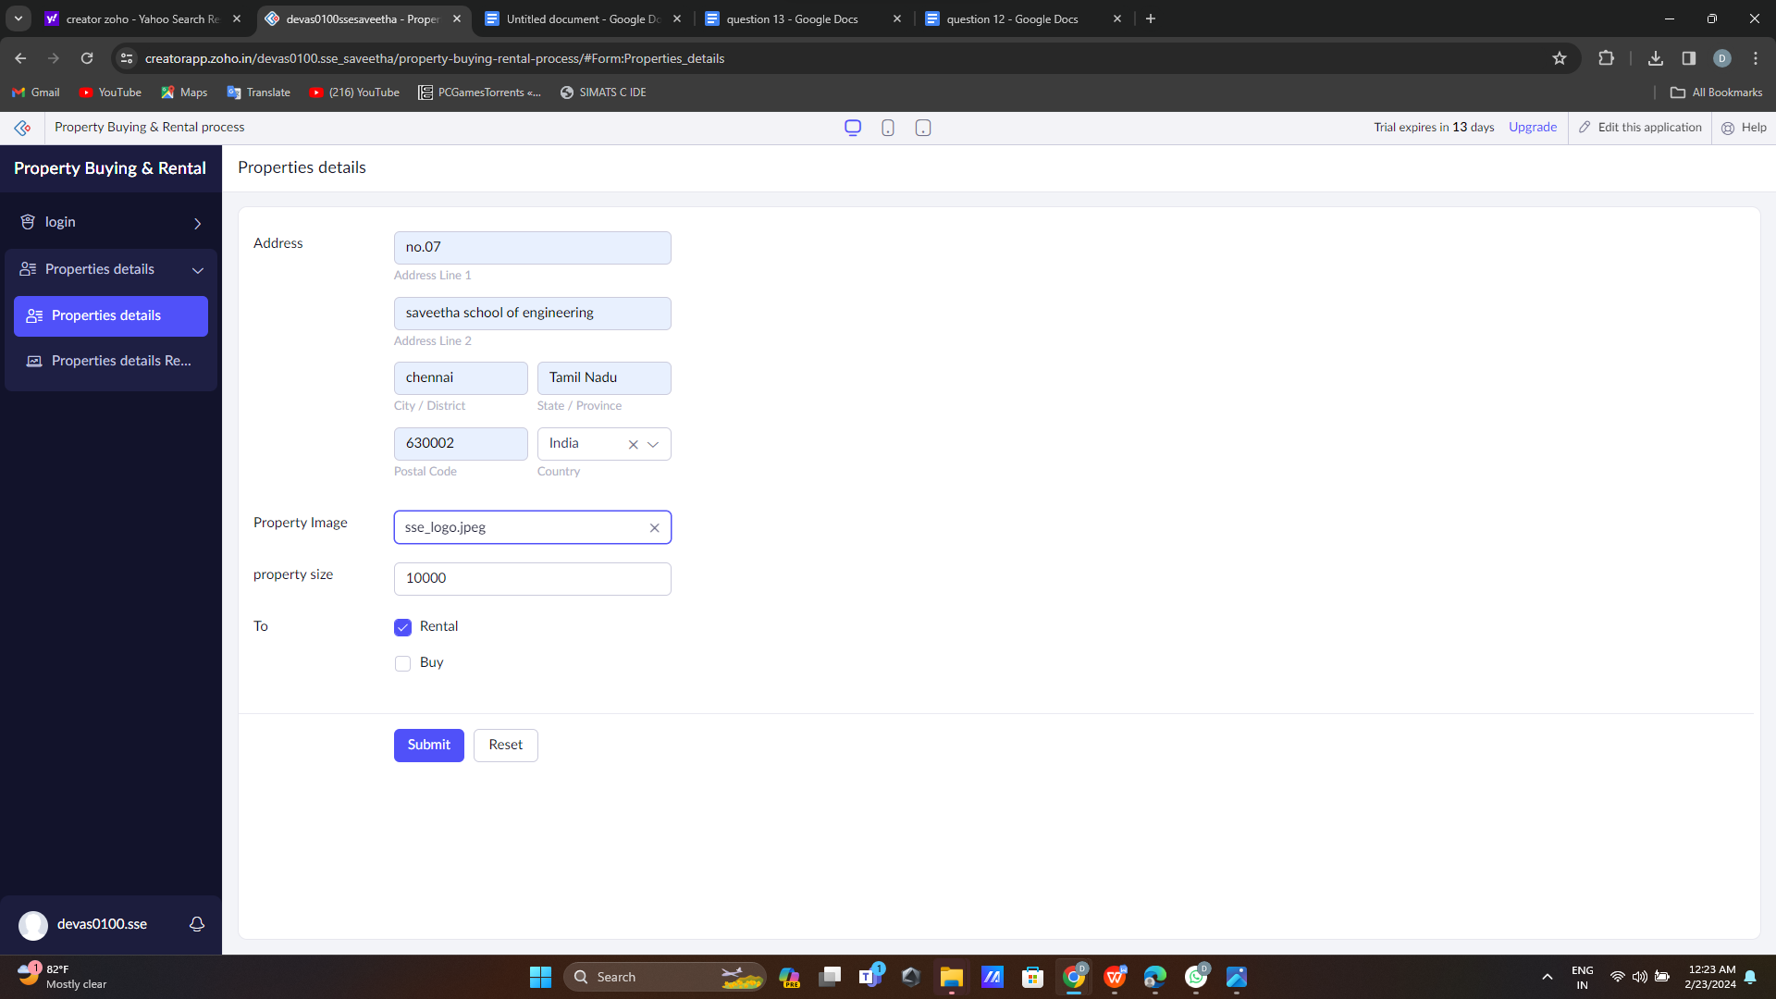

**Step 9:**

